COM3103

**Artificial Intelligence**

Introduction to A.I.

Art works, anyone? AI or human? 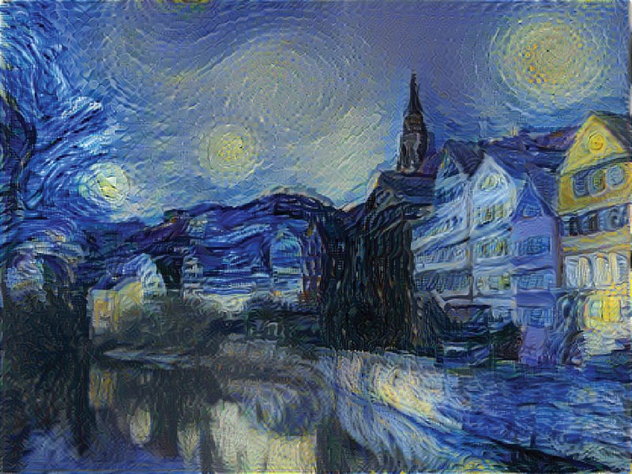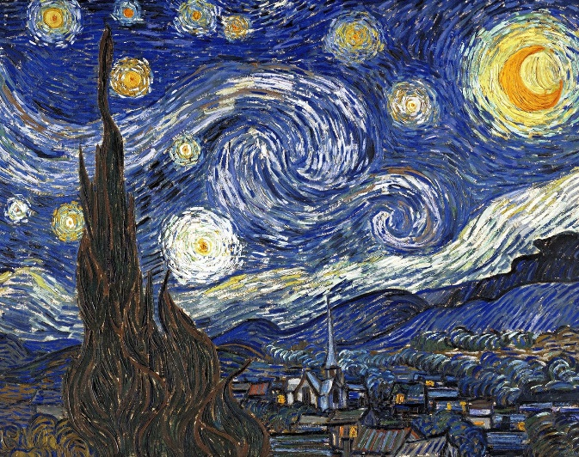

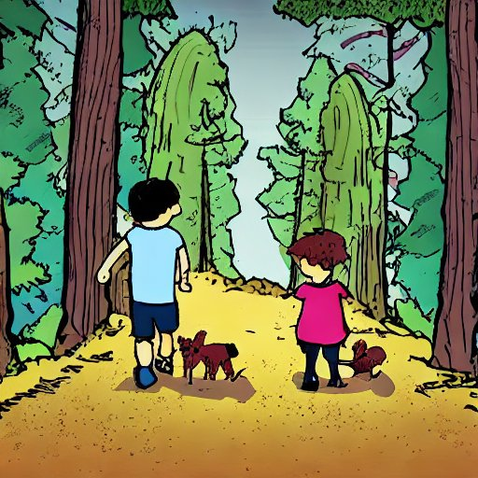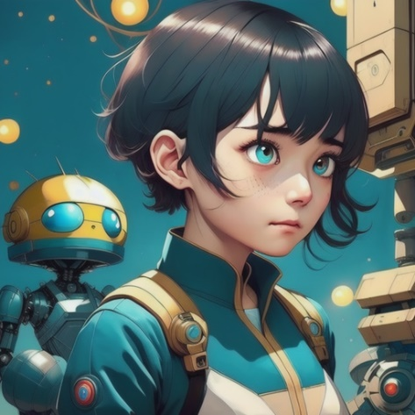Anyone likes comics? AI or human?

(C)

(B)

(A)

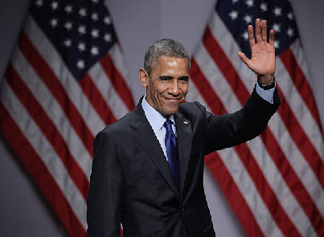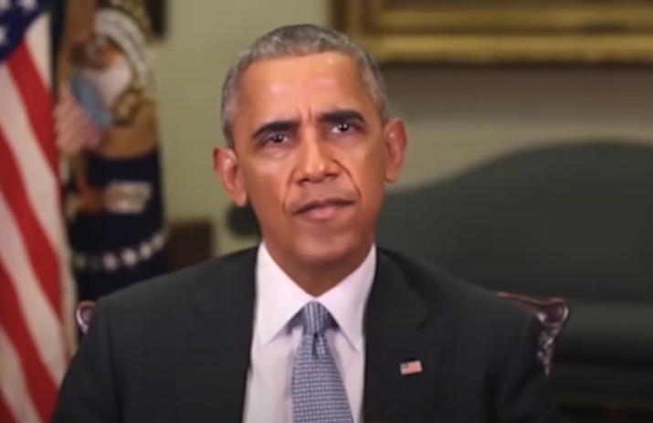

Which one is the "real" Obama?

Can you recognize these historical events?

What do they have in common?

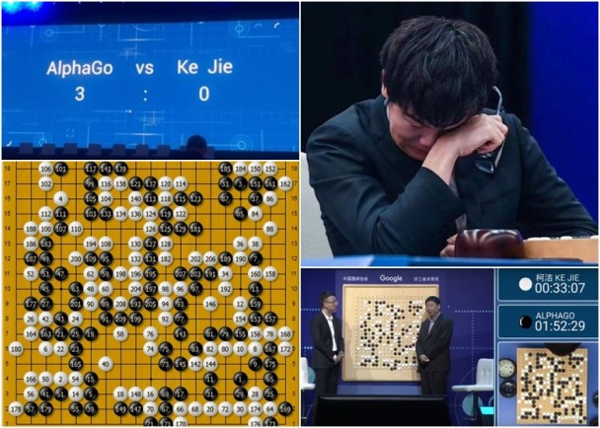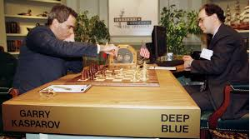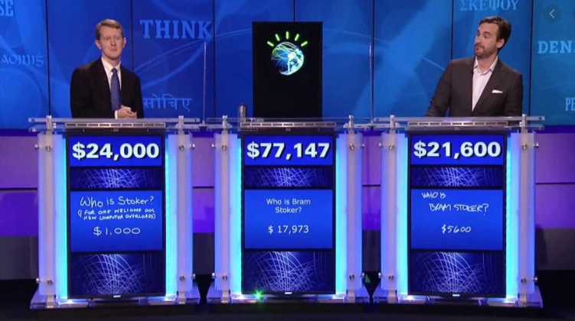

[**https://www.youtube.com/watch?v=P18EdAKuC1U**](https://www.youtube.com/watch?v=P18EdAKuC1U)

[**https://www.chess.com/article/view/deep-blue-kasparov-chess**](https://www.chess.com/article/view/deep-blue-kasparov-chess)

[**https://www.theverge.com/2017/5/25/15689462/alphago-ke-jie-game-2-result-google-deepmind-china**](https://www.theverge.com/2017/5/25/15689462/alphago-ke-jie-game-2-result-google-deepmind-china)

AI Poems or Tang Poems (唐詩)?

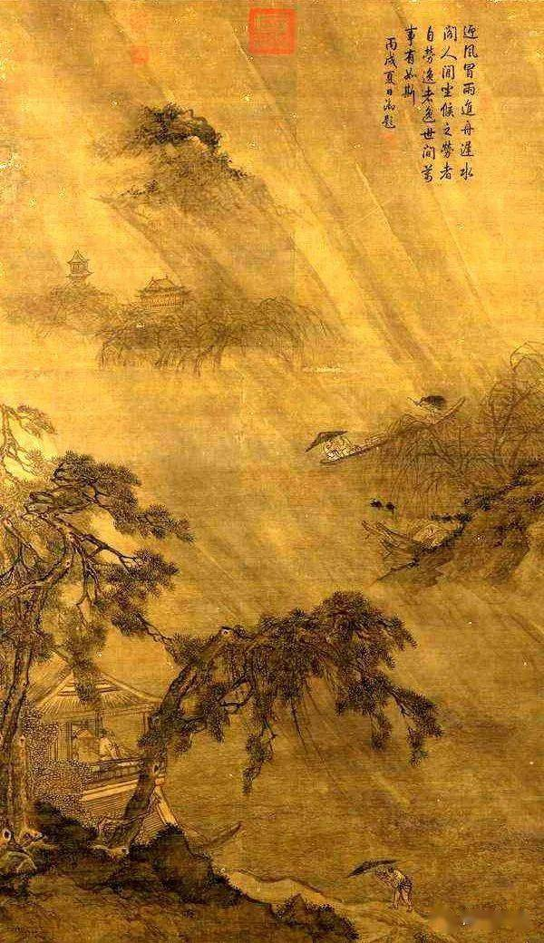

狂風呼嘯暴雨催，  
天地煞爛萬物哀。  
雷霆轟鳴驚夜寂，  
風雨交加夜未央。

烈日高懸天地間，

萬物焦枯盡悲哀。

燥熱炎夏人煎熬，

烈陽當空日色妝。

?

AI Poems or Tang Poems (唐詩)?



烈日高懸天地間，

萬物焦枯盡悲哀。

燥熱炎夏人煎熬，

烈陽當空日色妝。

狂風呼嘯暴雨催，  
天地煞爛萬物哀。  
雷霆轟鳴驚夜寂，  
風雨交加夜未央。

?

?

Introduction

* Computer software is matching human intelligence in some areas.
* Consider the software listed on the next two pages.
  + What are the differences?
  + Which group below (A or B) are the “intelligence” software? **Why?**

**Group A**

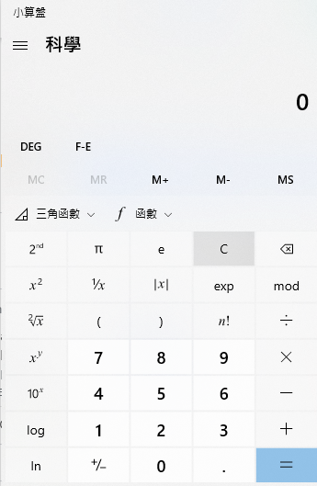 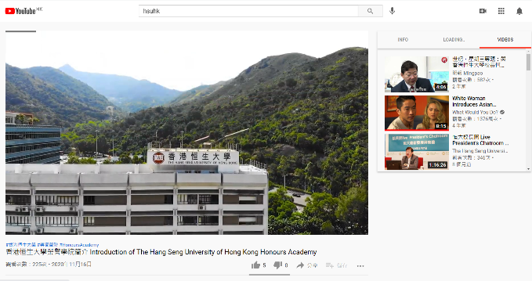**Group B**

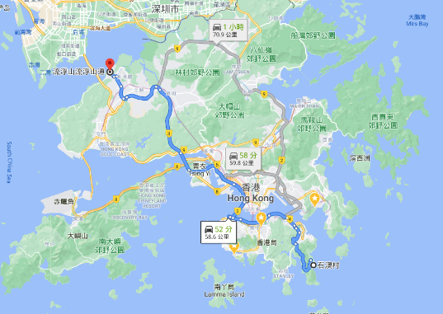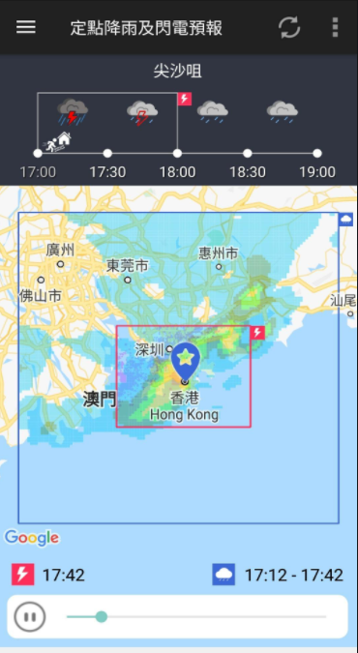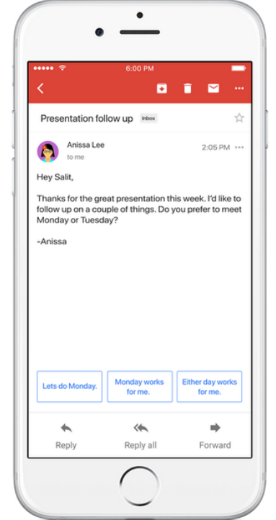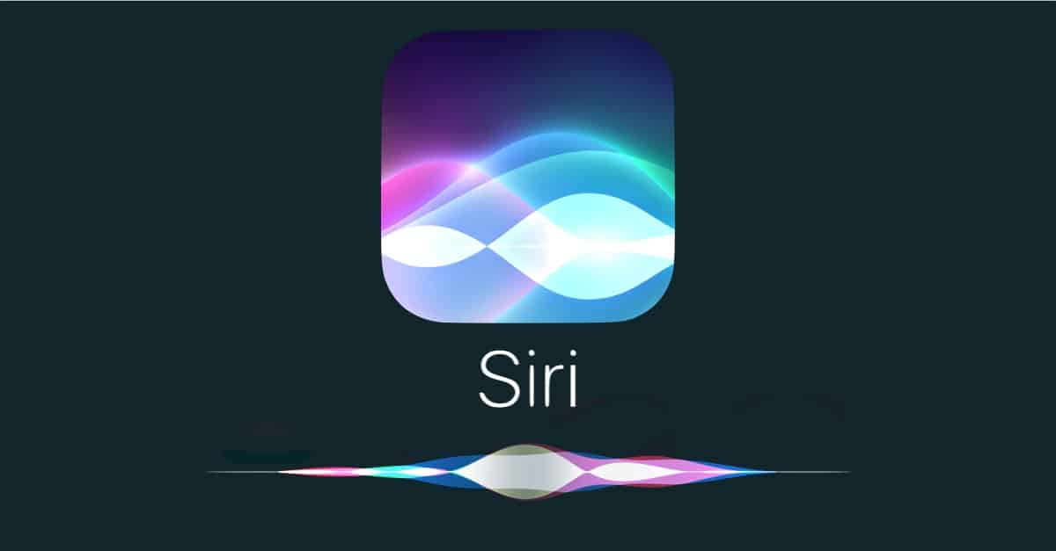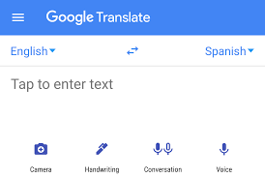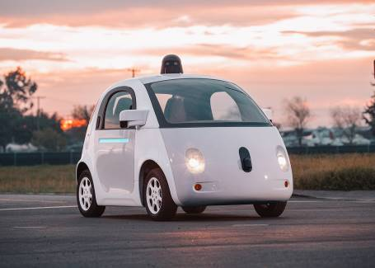Artificial Intelligence: What does it mean?

“*The science and engineering of making intelligent machines*.”

* - John McCarthy (“Father of AI”) in 1956

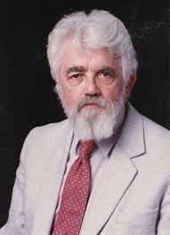**But “*Intelligent*” is hard to define!**

John McCarthy (1927 – 2011)

Professor at Stanford University

Received the Turing Award 1971

Propose artificial intelligence in 1956

Created the LISP language in 1958

His students developed the first computer program to play chess convincingly

Many "IQ Test" have questions like this:

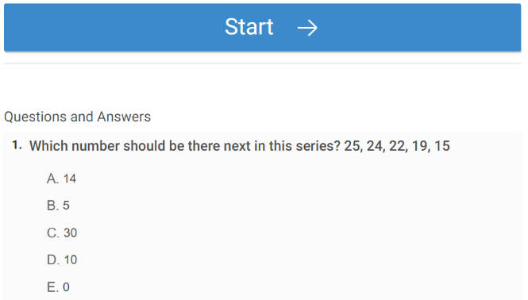

1. ***What are the next numbers in the sequences***

**[1,4,9,16,25,36, ?]**

**[1,2,5,10,17, ?]**

* If a kid can answer these questions quickly, is he/she

*intelligent*?

* And what if a program can answer these questions quickly?

<https://www.proprofs.com/quiz-school/story.php?title=iq-test_70kt>

1. ***The WOLF, SHEEP and CABBAGE Puzzle***

<https://www.proprofs.com/games/wolf-sheep-and-cabbage/>



If someone can solve this in a fraction of a second.

Is he/she smart? How about a computer?

1. **Three Cannibals and Three Missionaries**

https://www.novelgames.com/en/missionaries/

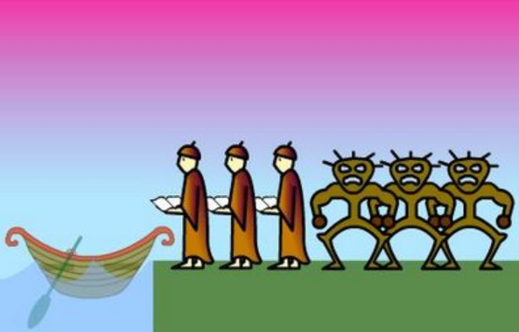

A program can solve this in a fraction of a second.

Intelligent?

***Two players board game (Chess / Go / Reversi) ?***

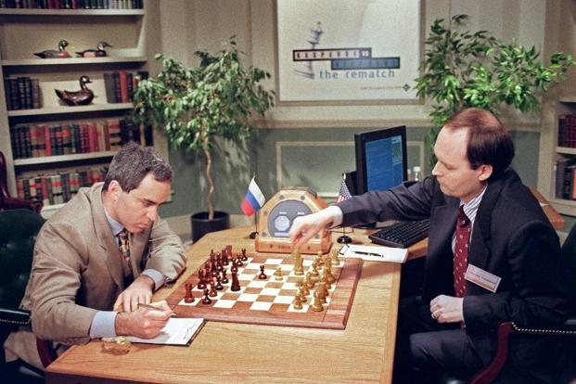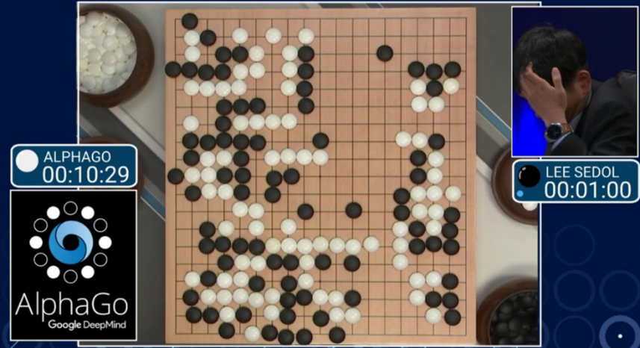

“Deep Blue”

by IBM

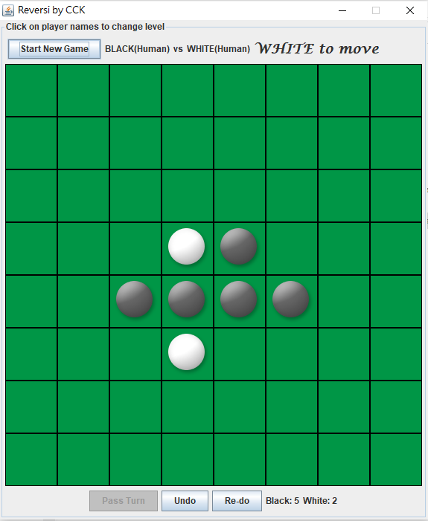

“AlphaGo”

by Google Deep Mind

“Manzana”

by CCK!

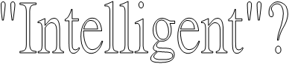***As well as these applications …***

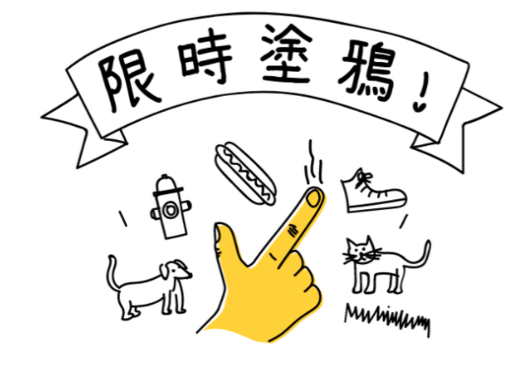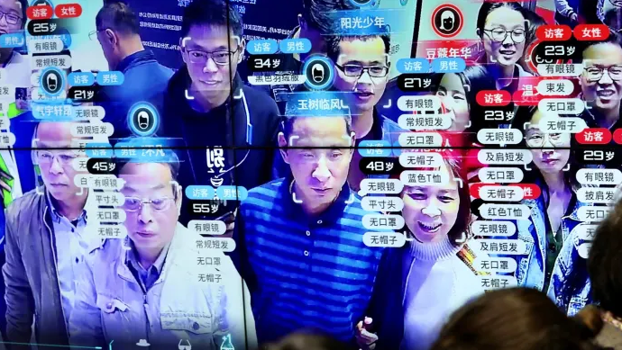



* 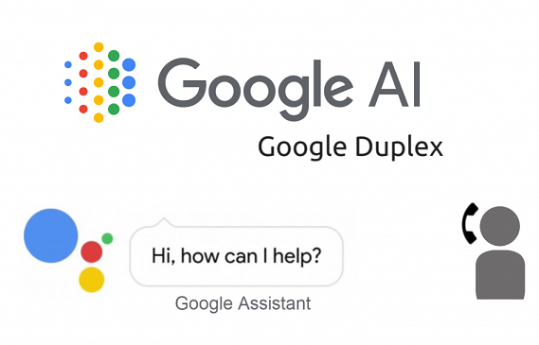

[Google Duplex](https://www.youtube.com/watch?v=D5VN56jQMWM&t=46s)

Pay by your Face

[Quick Draw with Google](https://quickdraw.withgoogle.com/)

Facial recognition

Are these AI?

* You may not be totally convinced that the above are all AI (especially after you have seen the codes!)

But all these were considered "intelligent" at some point in the past.

We actually have two kinds of AI

**Strong artificial intelligence** (a.k.a *artificial general intelligence*)

* + 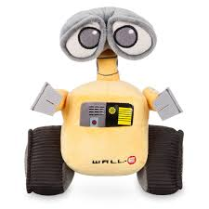AI systems can think and have a mind. Capable for solving many types of problems (like human).
  + Popular in Hollywood movies!

**Weak artificial intelligence** (a.k.a *narrow AI*)

* 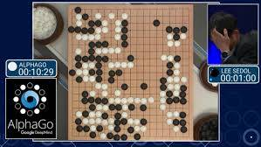AI Systems can act like they can think when applied to specific problems.

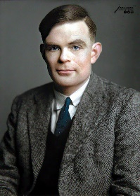

**Traditional Test for Strong A.I.: The Turing Test**

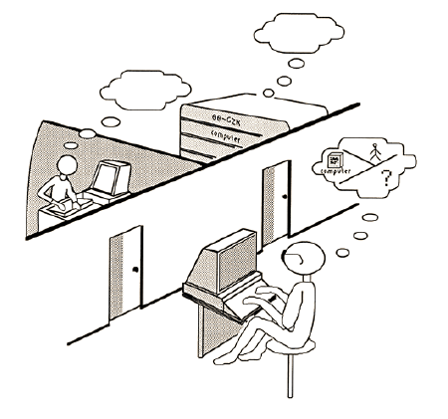Two rooms. A human in the first one. A computer or a human in the second one.

**Human in the first room:**

- Type in questions

**Computer/human in the second room:** - Process questions

- Return answers

**Human in the first room:**

- Receive the answers on a computer screen

- Decide: a computer or a human?

**Traditional Test for Strong A.I.: The Turing Test**

A computer passes the test if it can deceive human for more than 30% of the time.

Do you think the AI applications we have seen so far (e.g., ChatGPT or Google Duplex) have passed the Turing Test?

**A Test for Strong A.I.: The Turing Test**

* Until recently, no machines have passed the Turing test convincingly.
* But how about ChatGPT? Has it passed the Turing Test?
* 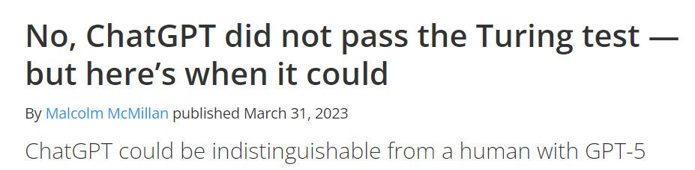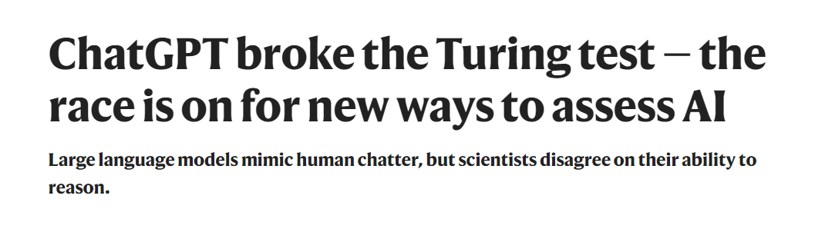It depends on who you are asking …

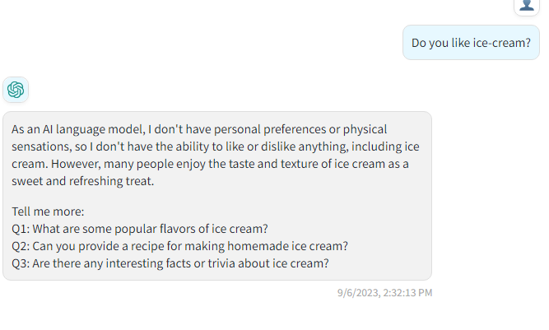

* But many people are not convinced that ChatGPT has already achieved Strong AI (yet).

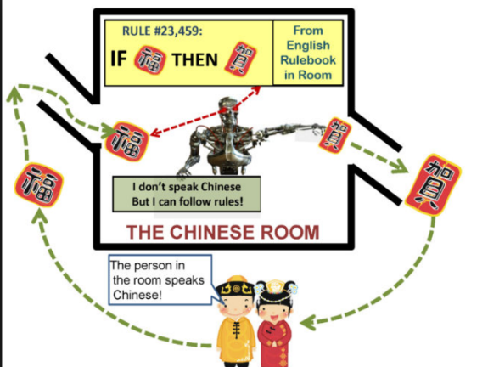**Criticism of the Turing Test: The Chinese room argument**- People outside a room write down questions in Chinese  
- A man inside the room answer by referring to a long long list of input-output mapping rules, without knowing Chinese himself.

- Does it mean that person knows Chinese>

And if your answer is NO, note that many "AI" systems

work in the same way …

**A more general definition (covering both strong AI and weak AI):**

“*Artificial Intelligence is the science of making machines do things that would require intelligence if done by man*” -- Marvin Minsky

Topics in AI

* Search algorithms
* Two-person games
* Automated reasoning
* Uncertainty reasoning (E.g., Fuzzy Logic)
* Evolutionary computing (E.g., Genetic Algorithm)
* Machine Learning
* Neural Networks and Deep Learning
* Robotics

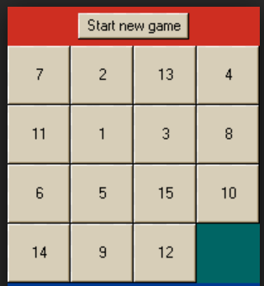**Search algorithms**

*Consider the 15 pieces puzzle: re-arrange the pieces in the correct order by sliding one piece at a time.*

**Tree Search:**

* 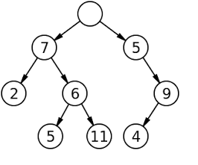Each node represents a state of the puzzle.
* The start state is on the top (the root)
* The edges represent possible actions
* Example:
  + - Depth first search and breadth first search
    - Hill climbing

**Two-person games**

* + As in Chess, Go, Tic-tac-toe …
  + Similar to tree search, but need to consider the available moves of your opponents as well.
  + Widely studied in the first 50 years of AI
  + 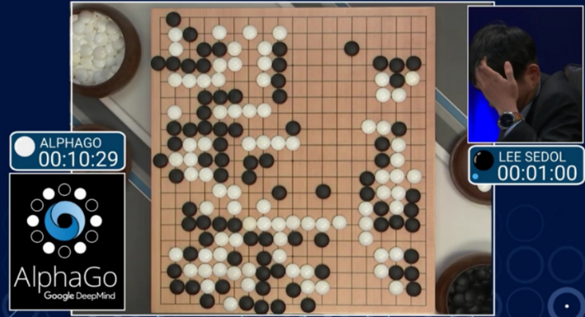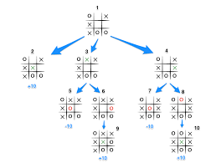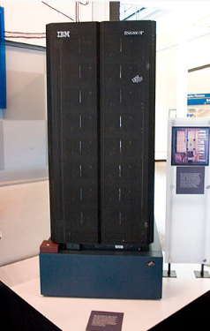****Example: Deep Blue and AlphaGo

**Automated reasoning**

*There are two persons, Paul and Mary.   
At least one person is a programmer.   
As least one person is an artist.*

*A person cannot be both a programmer and an artist.*

*Paul knows nothing about computers*

***Question:*** *Who is/are the artist(s)?*

* We can solve this using logical programming

**artist (Paul) | artist (Mary)   
programmer (Paul) | programmer (Mary)**

**programmer(x)=> know(computer, x)  
programmer(x)=> not artist(x)  
artist(x)=> not programmer(x)**

**not know(computer, Paul)**

* Example application: expert systems (e.g., Medicine, FinTech)

**Genetic Algorithm (G.A)**

* A type of evolutionary computing
* Mimic evolution of life.
* Maintain a pool of candidate solution, each solution encoded as long strings or numbers.
* 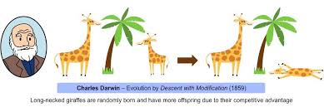New solutions are repeatedly generated by re-mixing the previous solutions. The best ones are kept to the next round.

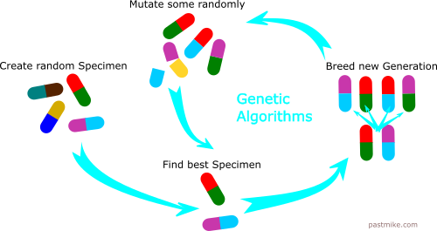

**Machine Learning**

* + One branch of AI.
  + 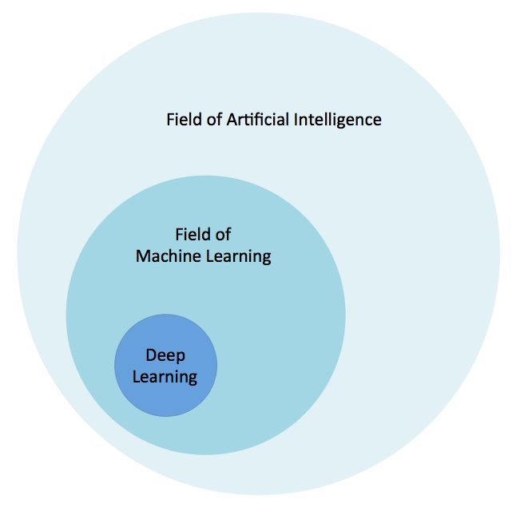Focuses on learning from experience or past data to make accurate predictions in future unseen data.
  + Many techniques
    - Supervised learning
    - Unsupervised learning (clustering)
    - Reinforcement learning

**Artificial Neural Networks and Deep Learning**

**Neural network:**

* + Inspired by the structure of the brain.
  + Neurons assigned into layers and connected to each other
  + Inputs are fed into the first layer
  + 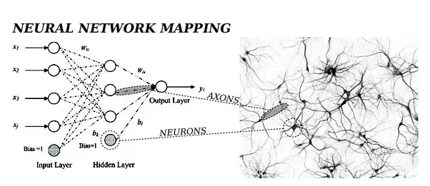The outputs of each layer depend on the outputs and weights of the previous layers

**Artificial Neural Networks and Deep Learning**

**Deep neural network (Deep learning):**

* 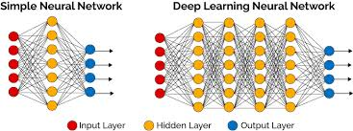Large neural networks with multiple layers, usually using specialized computers
* Many applications in recent years
  + Computer vision
  + Speech recognition
  + Natural language processing

A Brief History of AI

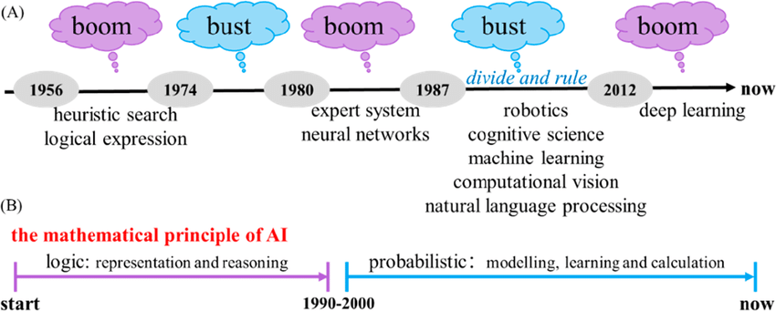

**Classic AI**

* Early period (~1950s to 1970s)
  + Searching and simple neural networks
  + Not much progress after initial excitement
  + Stalled in the 1970s (the “1st AI winter”)
* Second period (~1950s to 1970s)
  + Enhanced Neural Network in the 1980s and Expert Systems
  + 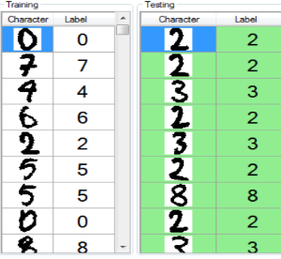Some early applications
    - Character recognitions
    - 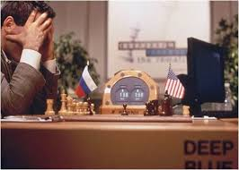clinical decision support Expert Systems
    - Game playing (e.g., IBM’s Deep Blue)

**The 2nd AI Winter**

* Progress in AI stalled again after 1990s.
* Reasons
  + Less successful in handling harder problems
  + Out-performed by more simple statistic-based (non-AI) methods
* Results
  + The Second “AI Winter”.
  + Research funding greatly reduced
  + Many researchers turn to other related areas (e.g., data technology)

**The end of the “2nd AI Winter”**

* New AI computation algorithms
  + - Some computer scientists did not give up during the “AI winter”
    - They discovered some vital improvement to the previous methods (especially in the neural networks), which enables *Deep Learning*.
* Advances in computation hardware
  + - Faster GPUs[1], which can perform multiple calculations in parallel.
    - Cheaper data storage
* The new advances allow the development of more powerful AI methods that can handle much larger amount of data faster than before

**Rise of Modern AI**

**The “AI Revolution”: What triggers it**

* Development of more powerful AI methods (e.g., deep learning)
* Availability of Big Data[2]

**Results**

* Big companies (Microsoft, Google, IBM) quickly recognized its potential
* Many successful applications
  + Computer vision, speech recognition, machine translation

**Your Task This Week**

* **Install Python (version 3.11 recommended)** on your computer (if you want to use your own computer for your homework).
* See Moodle for the download link

1. GPU: Graphical Processing Units. They are used by modern AI to perform many computations in parallel.
2. Big data is not an absolute requirement for modern AI, but it make modern AI more powerful and more accurate